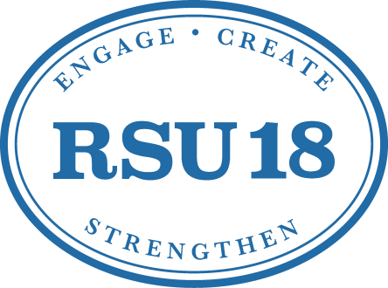

Substitute Information
Thank you for your interest in becoming a substitute with Regional School Unit No. 18. Our district is composed of eight schools that encompass the towns of Belgrade, China, Oakland, Sidney and Rome. The schools are broken down as follows:
Belgrade Central School | Belgrade | Pre-K to Grade 5
China Primary School | China | Pre-K To Grade 4
China Middle School | China | Grade 5 to Grade 8
Atwood Primary School | Oakland | Pre-K to Grade 2
Williams Elementary School | Oakland | Grade 3 to Grade 5
Messalonskee Middle School | Oakland | Grade 6 to Grade 8 (all towns except China)
Messalonskee High School | Oakland | Grade 9 to Grade 12 (all towns with China having school choice and many China students attending Erskine Academy)
James H. Bean School | Sidney | Pre-K to Grade 5

In order to be employed by a school district, you will need to complete fingerprints and a background check with the Maine Department of Education (MDOE). This is referred to as getting your CHRC certification or criminal history records check.
- Step #1 – Print off, complete and mail the Application Approval Form with a $15.00 fee to the MDOE.
- Step #2 – Register, pay and schedule an appointment to be finger printed through IdentoGo with a $55.00 fee.
Step #1 and 2 can be completed at this location: https://www.maine.gov/doe/cert/fingerprinting/index.html

The CHRC certification process can take up to six (6) weeks to complete. The MDOE will not send the certification to you. You will need to check your status online and print your certification at this location:
https://neo.maine.gov/doe/neo/TeacherCertification/TeacherCertification

The district has substitute employment opportunities in the following areas at the following hourly rates:
Teacher/Aide/Monitor – $10.60 Secretarial – $12.00
Custodian – $11.25 Nurse – $21.00
Nutrition Worker – $10.50 Nutrition Supervisor $12.65
Van Driver –$10.75 Bus Driver – $15.00

Long term substitute teaching positions are also available at the following daily rates when hired initially for a long term position that is 11 days or more in duration:

Long Term Teacher Sub – $100.00
Long Term Teacher Sub (certified teacher) – $145.00

To see the current employment opportunities the district has, please visit the RSU 18 website at the location below:
https://rsu18.org/about-us/employment-opportunities/

Each position will have a red apply box off to the side. You will click on that box to start the online application process. You will need to have your CHRC certification print out from the MDOE website available to upload to your application or you will be unable to submit it.

All employees of Regional School Unit No. 18 are required to comply with FERPA. The Family Educational Rights and Privacy Act (FERPA) (20 U.S.C. § 1232g; 34 CFR Part 99) is a Federal law that protects the privacy of student education records. FERPA gives parents certain rights with respect to their children's education records. These rights transfer to the student when he or she reaches the age of 18 or attends a school beyond the high school level.
If you have any questions, feel free to contact Kristi Farrell through e-mail at kfarrell@rsu18.org or by phone at 465-7384 extension 2658.

